**AVL Tree**

[http://btechsmartclass.com/DS/images/Next.png](http://btechsmartclass.com/DS/U5_T3.html)

AVL tree is a self balanced binary search tree. That means, an AVL tree is also a binary search tree but it is a balanced tree. A binary tree is said to be balanced, if the difference between the hieghts of left and right subtrees of every node in the tree is either -1, 0 or +1. In other words, a binary tree is said to be balanced if for every node, height of its children differ by at most one. In an AVL tree, every node maintains a extra information known as **balance factor**. The AVL tree was introduced in the year of 1962 by G.M. Adelson-Velsky and E.M. Landis.  
  
An AVL tree is defined as follows...

**An AVL tree is a balanced binary search tree. In an AVL tree, balance factor of every node is either -1, 0 or +1.**

Balance factor of a node is the difference between the heights of left and right subtrees of that node. The balance factor of a node is calculated either **height of left subtree - height of right subtree** (OR) **height of right subtree - height of left subtree**. In the following explanation, we are calculating as follows...

**Balance factor = heightOfLeftSubtree - heightOfRightSubtree**

**Example**

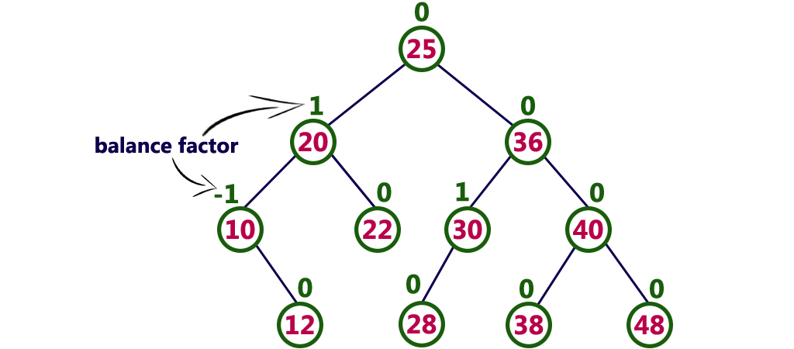

The above tree is a binary search tree and every node is satisfying balance factor condition. So this tree is said to be an AVL tree.

**Every AVL Tree is a binary search tree but all the Binary Search Trees need not to be AVL trees.**